ACT Civil and Administrative Tribunal

Digital Transformation due to COVID-19

Project Plan

Purpose: Research on Digital Transformation due to COVID-19

TABLE OF CONTENTS

1 INTRODUCTION 3
2 PROJECT NAME 3
3 PROJECT PERSONNEL 3
3.1 The Sponsor’s Name 3
3.2 Project manager and key team members 3
4 PROJECT DESCRIPTION 3
5 SCOPE 4
5.1 Business Rules 4
5.2 Assumptions 4
5.3 WBS (Work Breakdown Structure) 5
6 PROJECT DELIVERABLES 8
7 ROLES AND RESPONSIBILITIES 8
8 PROJECT MILESTONE & KPI’s 8
9 ORGANIZATIONAL CHART 10
10 TECHNICAL APPROACH 10
11 RESOURCES 11
11.1 Hardware 11
11.2 Software 11
12 MANAGEMENT APPROACH 11
12.1 Quality Management 11
12.2 Risk Management 12
12.3 Communication Management 15
12.4 Configuration Management 16
13 CHANGE CONTROL 16
14 ISSUES AND PROBLEMS 17
15 SIGN OFF: 17
16 QUALITY ASSURANCE 18

INTRODUCTION

This report proposes a plan to research in-depth on how the ACT Tribunal has transformed their business model as a result of COVID-19 outbreak, the digital transformation in and the role of technology. ACAT is an independent body that hears and determines a range of cases and disputes in the ACT. There are various organisational levels at ACAT, they are ACAT President and supported by a team of ACAT Members and registry staff. ACAT ensures that the procedures are as simple, quick, inexpensive and informal as is consistent with achieving justice. Natural justice and procedural fairness are also observed. Applications for ACAT to determine a matter can be lodged by individuals, companies, government agencies and occupational regulatory authorities.

PROJECT NAME
Digital Transformation due to COVID-19

PROJECT DESCRIPTION
This project will describe the digital transformation in the business model of ACT Civil and Administrative Tribunal during the COVID-19 outbreak. It will discuss the benefits of the new business model at the ACAT members and registry staff level, whether this model is easy to adapt, the problems faced by the employees in adapting this model, advantages and disadvantages of this business model and the future of this transformation. The role of technology will also be discussed, making it possible for this digital transformation. The goal of the project is to study the transformation in the business model of the Tribunal after COVID-19 and discuss the future of this transformation. The estimated time for the research is 2 months i.e., the research will be completed by 5/05/2021. The estimated cost of the project is $ 5000.

SCOPE
Whilst COVID-19 has brought many changes in the lifestyle, way of working, at the same time it has brought changes to business models of various organisations. The scope of the project is as follows.

In Scope -
1) To describe the digital transformation in the ACT Tribunal due to COVID 19 in the form of a report.
2) To compare the merits and demerits of the business model.
3) To predict the future of this digital transformation.
4) To prepare a set of 5 questions related to the digital transformation for the purpose of the interview.
5) Interviewing the employees of Tribunal and recording their response.

Out of Scope-
1) Comparison between the pre-covid and post-covid business model.
2) Digital transformations in the Tribunal before COVID-19.

The scope of research is limited to study the business model involved in the registry staff department of the ACT Tribunal. The employees that will be interviewed are limited to 3. The hardware that will be involved will be a mobile phone to record the responses of the employees during the interview. The software involved will only be Microsoft Word for the purpose of writing the report as the exact nature of the work is research.

Business Rules
- The personal information of the employees of Tribunal will remain confidential during the interview.
- The responses to the questions of the interview will not be shared with other employees.
- The principles of ethics will be followed while writing the report.
- While conducting interviews social distancing will be followed.

Assumptions
- The employees will answer the interview questions in an honest and frank manner.
- Multiple perspectives including the voice of employees is included in this research.
- The cost of the project does not exceed the project budget.

WBS (Work Breakdown Structure)
Digital Transformation due to COVID-19
1. Initialize
1.1 Determine the organisation to research on
1.2 Arrange meeting with project sponsor.
1.3 Prepare project plan.
1.4 Develop project proposal.
1.5 Define roles and responsibilities.
1.6 Define scope of project.
1.7 Define budget, time and resources required for project.
1.8 Develop project charter.
1.9 Determine the stakeholders.
1.10 Define project milestone.
2. Planning
2.1 Plan structure of research
2.2 Record meeting minutes
2.4 Planning workflow dependencies
2.5 Allocate tasks to team members
2.6 Procurement planning
2.7 Sharing key details with sponsor
2.8 Finalise all project planning
2.9 Project plan approval
3. Analysis
3.1 Conduct needs analysis
3.2 Define strategies
3.3 Develop delivery timeline
3.4 Secure required resources
3.4 Define strategies
4. Research
4.1 Collect data, facts
4.2 Prepare questions for interview
4.3 Identify framework of research
4.4 Reading similar research papers
4.4 Document sources
5. Interview
5.1 Organise meeting with organization.
5.2 Conduct interviews
5.3 Gather responses.
5.4 Record feedback
6. Review
6.1 Proofreading of the report
6.2 Update the report.
6.3 Review report with sponsor
7. Closing
7.1 Document project outcomes
7.2 Project closure report
7.3 Close project

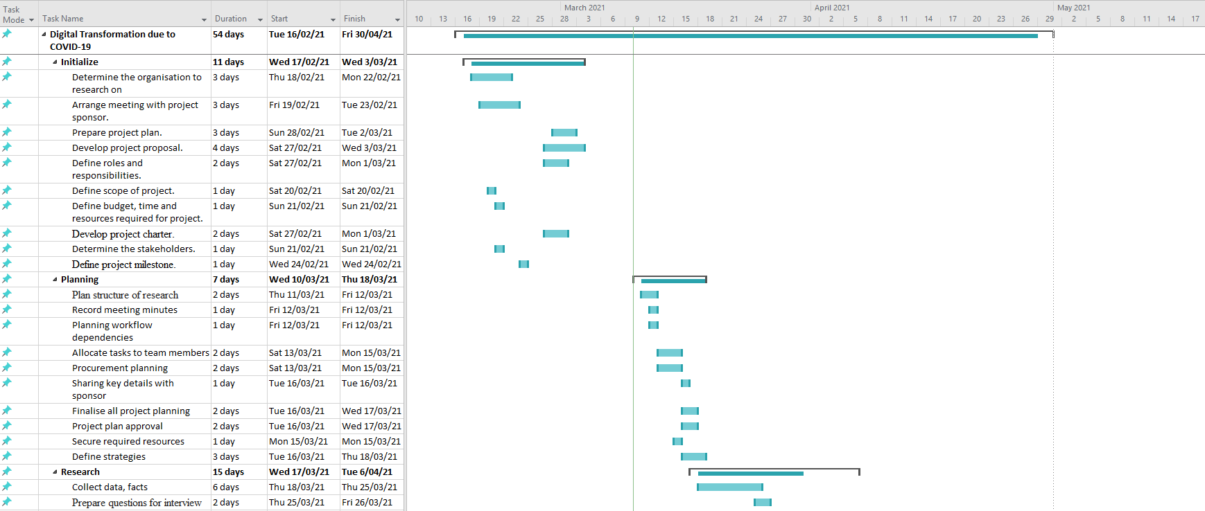
Gantt Chart
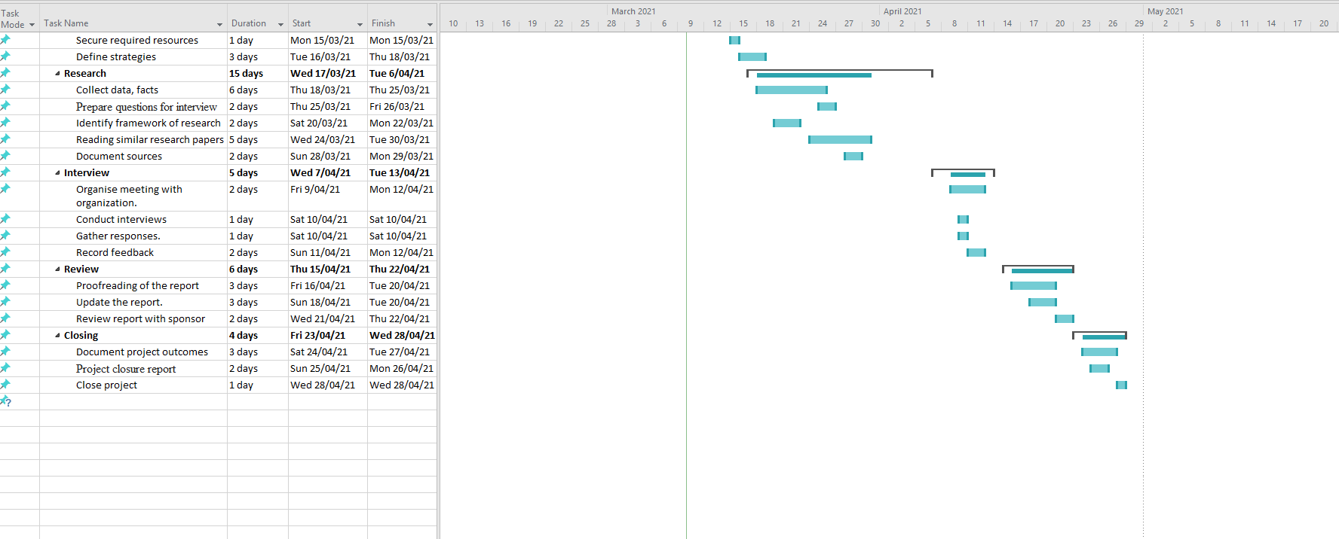

PROJECT DELIVERABLES

The deliverables that will be produced as a part of this project will be a research report on digital transformation due to COVID-19 in Tribunal department. The report will include the discussion about the new business model of the Tribunal after COVID-19, merits and demerits of the model and the future of this transformation. The response of the interview questions will also be included in the report.

ROLES AND RESPONSIBILITIES

Team Member | Role | Responsibilities
Zubair | Project Manager | - To research about the Tribunal’s business model’s digital transformation.  - Keeping the track of deliverables and cost of the project.  - Monitoring progress of the project.
Gautam | Document Reviewer | - Examine the data, responses for relevance and confidentiality.  - Reviewing the report for formatting and grammatical errors.
Harry | Principal Investigator | - To conduct interviews and prepare interview questions.  - To coordinate with the Tribunal’s personnel to assure policies and procedures.
Sulaiman | Research Coordinator | - To analyse the results of the interview and describe it in the report.  - Summarizing the information of charts and graphs from research papers.

PROJECT MILESTONE & KPI’s
Throughout this project, a small group of milestones have been identified. These milestones have been carefully chosen and planned to best fit the time available to complete the project as well as the availability of project team members and potential interviewees.

Key Performance Indicators (KPIs) are key indicators of progress toward an intended result. KPIs provide a focus for strategic and operational improvement, create an analytical basis for decision making and help focus attention on what matters most. (kpi.org 2021)

Specific KPI factors have been identified which will indicate whether group milestones have or are being achieved. These KPI factors include sufficient and clear evidence that progress is being made towards the reports desired result, whether the correct data is being measured and analysed to help inform decision making, offering a comparison between primary and secondary sources as well as if the reporting process is efficient, timely, compliant with government and business regulation and of the highest quality.

Milestone 1 (22/03/21 - 28/03/21) - Week 7
During this week an ethics form will be sent out to potential businesses and organisations of interest. This form will comprise a confidentiality agreement as well as clearly outlining the purpose of the interview and its intentions.

Milestone 2 (29/03/2021 - 04/04/2021) - Week 8
During this week the interviews will be held. If the business agrees to the ethics form the team will either go to the business itself or conduct interviews via zoom. These interviews will focus on the project question and will be completed in a professional manner.

Milestone 3 (05/04/2021 - 11/04/2021) - Week 9
Once the data has been collected, analysis and research will begin as the final report will be drafted and reviewed by all team members.

Milestone 4 (7/5) - Week 12
The final report including interview answers, analysis and research will be submitted.

ORGANIZATIONAL CHART

TECHNICAL APPROACH
When building the technical approach, understanding the stakeholder’s needs is essential to create a well informed and accurate report. One of the main technical approaches which will be taken to complete this report is the waterfall methodology. This technical methodology focuses on planning the project fully, and then after splitting the project into phases and executing one at a time. As previously indicated in the project milestones, phases have been outlined where research, interviews and analysis have all been identified.

Each phase will include specific steps, process and features relevant to the work being completed and clearly identifiable for the project team and the interviewees and stakeholders involved. For the ethics form, all information regarding interviewees personal information will be kept in a confidential environment where no one can access the data for use. All interview data taken during week 8 will be recorded both through an audio capturing software as well as being handwritten via a microsoft word document. All information gathered from the interviews will then be carefully organised and implemented into the final report.

RESOURCES

Hardware
Hardware is an essential aspect of the report and interview as specific hardware requirements are needed to effectively gather, organise and report on information.

- Computers: Computer will be an essential hardware needed for interviewing and reporting, they will allow to gather information all in one place as well as assist in research and development
- Mobile Phone: This hardware will be useful in recording the audio of the interviews so that data is easily accessible.

Software
Software is essential for offering programs and applications that will assist in gathering and reporting information.

- Microsoft Word: Microsoft Word is a powerful tool which is useful for reporting, storing information as well sharing with stakeholders and team members.
- Audio recording software: This will be especially useful in the interview phase, as recording what the interviewer and interviewee say will help efficiency when reporting as well as having information that is easily accessible.

MANAGEMENT APPROACH

Quality Management
Our main quality focus will be on structure of elements of final report which will be as follow.
Front Cover →Header/footers → Summary →Table of Contents → Introduction → Brief → Scope of the Report→ Documents Provided → Relevant Background information →Qualification → Copyright → Data Collection →Appraisal → Conclusions → Recommendations → Bibliography

The above given structure will be followed strictly because it is the survey report which would be based on one of the government department and it needs to be written in professionally because they might ask for the copy of the report as well. The final report will be sent to the sponsor for a review before submission as the sponsor might need some changes in the final version.

Risk Management

Risk Identification | Risk Assessment | Risk Action
Risk Description | Consequences/Risk Rating | Strategy | By Whom | By When
1. No research on report, Poor communication between project team and no checks | High/High Risk | Have a regular meeting with team, discuss all points | Project Team | Ongoing Project Until completion
2.Team does not have required knowledge to write report on digital transformation in government sector, did not researched on Tribunal | High/High Risk | Send regular updates to Dr. Blooma John | Project Team | Ongoing Project Until completion
3. Approval of interview with Tribunal | Low/Low Risk | Get permission from Dr. Blooma John | Project Team | By Week 4
4. Starting work on report | Low/ Low Risk | Project team will divide their parts and start gathering information | Project Team | Week 5
5. Send invitation of interview to Tribunal | High/High Risk | With the approval of Dr. Blooma John send official invitation to tribunal | Project Manager | Week 6
6. Prepare for interview | High/High Risk | Project team will prepare for all questionary for interview and update to Dr. Blooma John | Project Team | Week 6
7. Updates from tribunal regarding interview, specific requirements | Low/Medium Risk | Fulfill tribunal requirements with the permission of Dr. Blooma John | Project Manager | Week 7
8.Interview with tribunal officials, specific questions, privacy | High/High Risk | On interview day specific questions will be asked related to topic and consent form will be signed for the privacy purpose of the officials from tribunal. | Project Manager, Principal Investigator | Week 8
9.Insufficient time to complete project for team due to unexpected issues, team members did not submit their tasks on time. | High/Medium Risk | Have meeting with the team regularly for issues and check team member work on 3 to 4 days schedule specially when near to submission | Project Manager | Ongoing Project Until completion
10. Loss of project team member due unfinished work on time, illness, or any circumstances | High/Medium Risk | Immediately inform to unit convener and project sponsor and discuss the issue how to sort it out | Project Manager | When situation occurs
11. Sponsor unreachable due to any circumstance | High/Medium Risk | Immediately contact unit convener and asked to reach sponsor in a best appropriate way | Project Manager | When situation occurs
12. Loss of data due to virus or poor hardware storage | High/High Risk | Save all data on cloud and other portable devices and contact unit convener and project sponsor as necessary, also ask for additional time to complete the project if necessary. | Project Team | When situation occurs
13. Unable to fulfill client requirement due to time and difficult requirement | High/Medium Risk | Submit a change form with all functional requirements | Project Manager | Week10

Communication Management
All the communication will be done through group chat, so everyone is UpToDate with information and regarding meetings. Group chat will also help us to record all meetings and responses of the project team with date and time. All the documents related to the project report will be shared through Google docs with project team members so everyone knows who is doing which part and they can also share their reviews. On a weekly basis the report will be shared with the sponsor for updates regarding the project. Any requirement by the team will be notified through group chat so the responsible stakeholder can immediately fulfill the requirement.
Any verbal communication with sponsor or project team members will be written and it will be only shared with the project team through group chat. All the communication will be consent of privacy until or unless shared with the approval of Project sponsor and relevant department.

Configuration Management
All consideration will be taken to ensure project deliverable are appropriate.
- Project progress is discussed with the sponsor (Blooma John) in person and through emails to ensure that the project team is progressing on their tasks.
- Project team meetings are being attended on a weekly basis as scheduled and notes are taken to ensure weekly progress is carried out to finish the project on time.
- The task of every team member is noted with date of completion and its duration so the project manager can reschedule the other tasks accordingly.
- All project team members are using the same version of Microsoft Word so as to maintain uniformity and to avoid errors.
- WhatsApp group chat is the communication platform to immediately contact the team members regarding any unexpected issues.
- WBS will be followed strictly to make sure the project is delivered on time.

CHANGE CONTROL
The systematic process by which a system or product management is changed is referred to as change control. The research topic is based on the transformation of the system of service delivery for ACAT. Change control is an essential aspect to critic the process of change, although COVID-19 necessitated it. Although change control is set up to ensure that unnecessary changes are not made, it is of paramount importance that ACAT's transformation from manual services to digital services be accessed and verified according to the change and control perception standards (Galindo-Martín et al., 2019). This is to ensure that the move is useful, timely and cost-effective.
The six steps employed in the evaluation of the change at ACAT are.
1. The planning and evaluation of the scope of the change.
2. Assessment and analysis of the process of transformation.
3. A concrete review of the change with the approval of the directors and organizational leadership.
4. Building and testing the change before implementation
5. Implementation of the change.
6. Decision-making on whether to continue or do away with the change.

ISSUES AND PROBLEMS
The basis of the research is the authorization by either institution or organization that needs the research done. The school approves conducting a project and offers guidelines on how they are to be conducted. The data to be collected is authorized by the institution management that the researcher is interested in. Here is a list of essential ethical issues and challenges to consider throughout the research (Galindo-Martín et al., 2019).
1. The research should be developed from an original perspective, ensuring not to refer to other people's work without proper references.
2. Plagiarism is not accepted for any reason whatsoever.
3. The researcher is responsible for analysing, interpret and present the data appropriately.
4. The researcher should seek authorization from the organizational management to conduct the research.
5. The research should be conducted without prejudice, favour, or bias towards personal interest or monetary gain.

SIGN OFF:
Gautam Chona, Zubair Khawar Bajwa, Harry Riepon, Sulaiman Aleidy

COMMENTS……………………………………………………………………
……………………………………………………………………………………
SIGN
_____________________________________ _______________
Client Date

QUALITY ASSURANCE

This section specifies the quality assurance for this document

1. Process of Document Development
The process for creating this document will entail the school guidelines of a project requirements. It will be followed by the organizations under investigations structure of administration. The firm will define the direction of data collection and information confidentiality as regulated by the terms and conditions that company has laid down. The data analysis, findings, and interpretation will be guided by the statistical theories learnt in class. Alongside with research on the vital aspects of the company, COVID 19, and digital transformation, this document will be based on the latest information on effects of COVID 19 to firms.

2. Traceability
The report borrows largely from recognized literature, both from class and researched content. The school manual should be used as a reference point to develop this document. Without a guideline to develop the project, it would be impossible to come up with the project. Therefore, the first traceability factor is the school manual on project development and grading. The second traceable factor is the interviews, questionnaires, and information acquired from the organization. The official acceptance that the project is based on the organization from the directors of the organization is a traceable factor. The final traceability is the data collected and the consent indicated under the data analysis documented by the researchers.
The data is the foundation of the project’s findings and recommendations. The project manual is the guideline allowed by the school to be followed for acquiring academic excellence. The ACAT staff and directors’ consent to allow and fill out the project requirement drive the projects towards its completion. The value of traceability is based on the authorization by the people in charge of the organization and school for the project to be conducted.

3. Verification
This document is only defined as legal and meets the standards after the following people append their signature of authorization and confirmation that the information in these document has their consent.

1. The lecturer in charge of the project development, as a tool for examination, and assessment for academic qualification.

2. The staff of ACAT allowing to fill in the questionnaire, answer the questions and sign on the consent form.

3. The directors of ACAT allowing the organizational data and confidential information on digital transformation to be given.

4. The school taking liability on behalf of the students as they conduct the project.
All the approval documents will be attached with the report for reference purpose.

4. References
The knowledge sources employed involve:

- www.barrelltreecare.co.uk. (n.d.). Home» Barrell Tree Consultancy | UK Consultants and Expert Witness Services. [online] Available at: <https://www.barrelltreecare.co.uk/ >[Accessed 11 March 2021].

- 24hrco.com. 2021. Building the Technical Approach. [online] Available at: <https://24hrco.com/images/articles/html/BrookeCrouter_Jul12.html> [Accessed 11 March 2021].

- Kpi.org. 2021. What is a Key Performance Indicator (KPI)?. [online] Available at: <https://kpi.org/KPI-Basics> [Accessed 11 March 2021].

5. Document History
There are no previous versions of this document.

